ASSIGNMENT 2

Name : Akanksha Joshi

Roll No : B038

Batch : 3

Div : BTECH CS B

--------------------------------------------------------------------------------------------------------------------------------------

Create ﬂowcharts for the following problems

1.Calculate the average of three numbers. If average is greater than or equal to 75, print "Pass", else print "Fail".

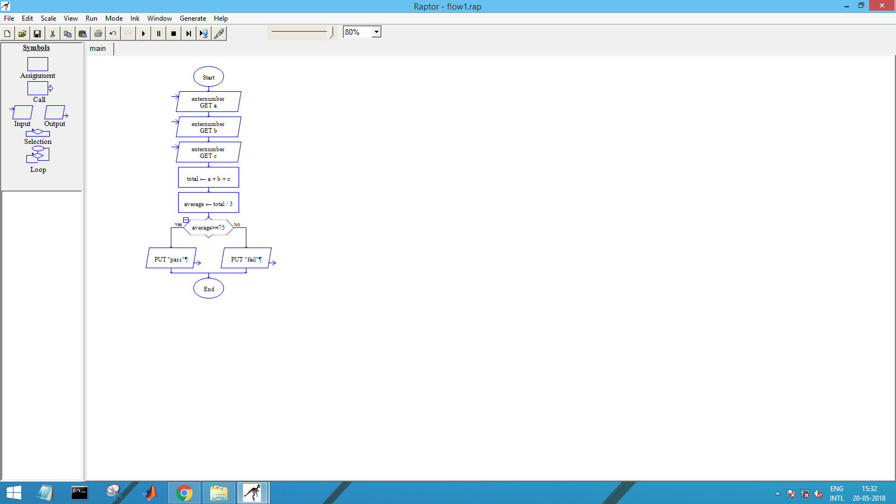

2. Calculate and print the factorial of a number.

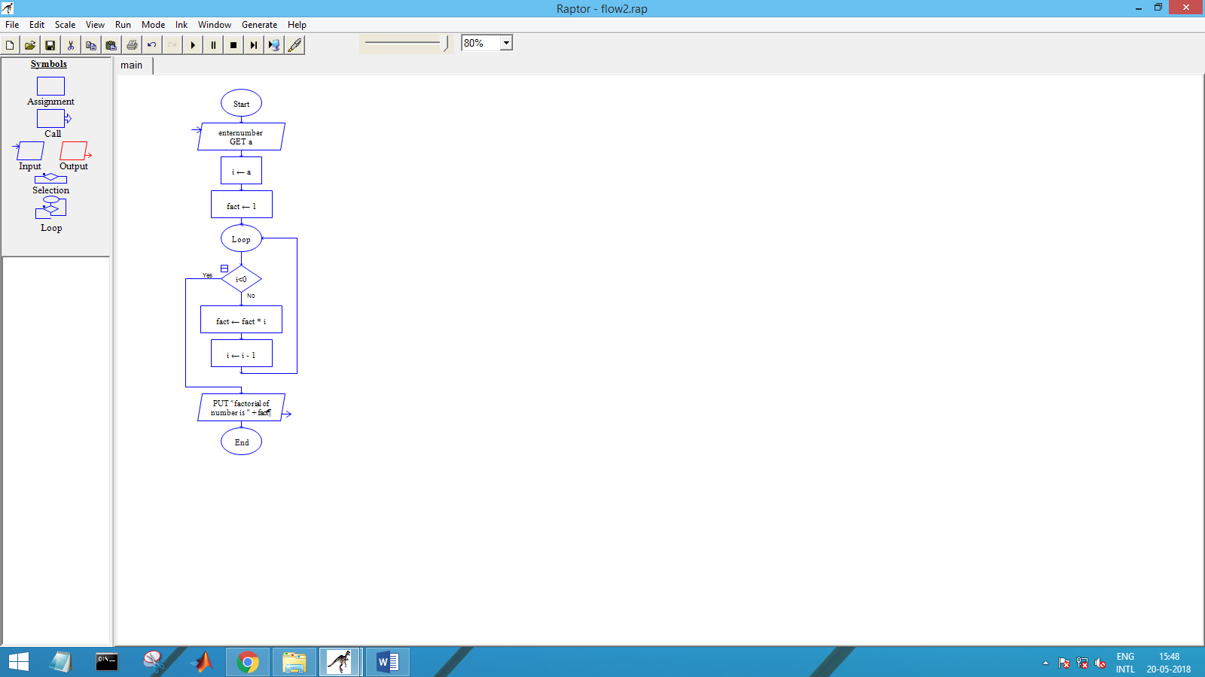

3. Accept the lengths of three sides of a triangle as input from the user. Based on the input, print if the given triangle is "Equilateral", "Isosceles" or "Scalene"

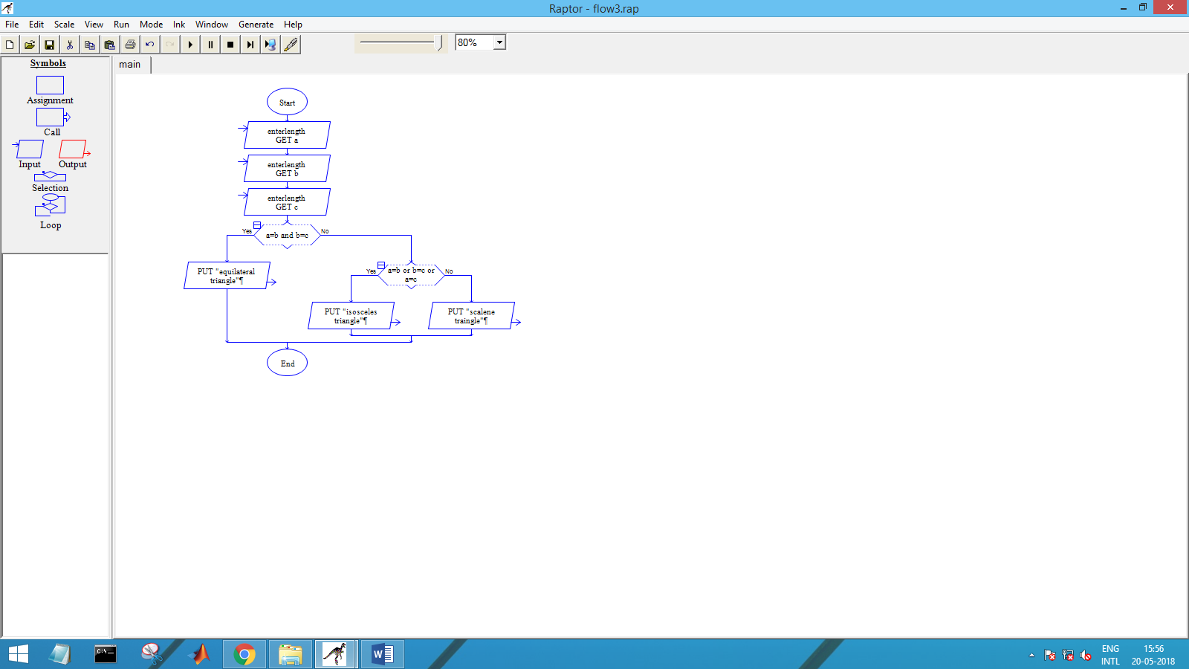

4. Accept the values of principal amount, rate of interest and number of years as an input from the user. Calculate and print the simple interest

